**Pelton Wheel Lab**

ME 436 Aerothermal Fluids Laboratory

Jeremy Maniago

Experiment #5

10/6/2023

Mechanical Engineering Dept.

The City College of New York, USA

# Abstract

In this experiment, we investigate the working principle of the Pelton Wheel, a type of impulse turbine and also the most commonly used. The goal of this experiment is to analyze the performance of the Pelton Wheel for different flow rates and rotational speeds by changing certain parameters of the contraption. This is achieved by changing the friction brake load on the wheel shaft and position of the nozzle regulating spear independently. The necessary data, which can be done by measuring the resultant flow rate, spring load, and turbine wheel rotational speeds, is then used to apply the mathematical analysis and plot visual results through MATLAB. What we observe from post-analysis is a decrease in efficiency when the wheel speed increases. It is concluded that although higher flow rates mean higher wheel speeds, the efficiency will decrease as both of those parameters increase.

# Introduction

In the Pelton Wheel contraption, a jet of water that is controlled by nozzle position is directed onto the Pelton Wheel’s buckets. The impingement of water jets onto the wheel cause jet streams directed sideways and outwards which produces a force on the bucket which then is converted into a torque on the shaft of the wheel. The objective is to analyze the efficiency change in relation to the wheel speeds. The data that we need is the mass on the brake load (W), the spring force (S), the wheel speed (N) via tachometer, the pressure (P), the brake wheel radius (r), and the volume flow rate (W), which is calculated from:

|  |  |  |
| --- | --- | --- |
|  |  | *(1)* |

With these variables, we can then calculate the torque from the equation:

|  |  |  |
| --- | --- | --- |
|  |  | *(2)* |

The power input and the power output can be calculated from the following equations:

|  |  |  |
| --- | --- | --- |
|  |  | *(3)* |
|  |  |  |
|  |  | *(4)* |

Finally, the efficiency is found through:

|  |  |  |
| --- | --- | --- |
|  |  | *(5)* |

# Experimental Setup and Procedure

The contraption is made up of the Pelton Wheel, the nozzle jet, a sink, a tank, and a pump in a two-level table setup. On the bottom level, the pump moves water from the tank up into the upper level where it ejects out of the nozzle and into the Pelton Wheel bucket. The water is then spilled out into a spillway and into a sink, which drains directly beneath back into the tank reservoir. The pump is at a constant power, and the amount of water in the entire system stays constant. The nozzle position is controlled with a knob, and the connection draining the water from the sink to the tank can be closed with a valve. The masses placed onto the brake load is listed for each mass. The spring has an indicator in kilograms. The flowrate is calculated by closing the valve from the sink drain and timing in seconds, with a stopwatch, when the volume of water in a separate cylinder (marked with increments in Liters) goes from 0L to 20L, then using equation *(1)*. The pressure is shown in an analog readout in Bar units. The revolutions per minute of the wheel is measured by using a tachometer which utilizes a laser that is focused on one part of the rotating shaft wheel. The procedure is as follows: First, we have to ensure that all the brake loads are removed, and that the sink drain valve is opened. After this, we can turn on the pump and carefully turn the knob that controls the nozzle position counterclockwise carefully so that the pressure analog readout reads 0.5 Bar. Now we can use the tachometer to measure the wheel speed for 10 trials – this will be used for the tachometer uncertainty. Close the drain valve and when the water reaches 0L, start a stopwatch. Stop the stopwatch when the water reaches 20L and record the time in seconds. Reopen the valve and record the spring mass on its readout as well as the wheel speed using the tachometer. This is for a mass of 0 grams. Now the masses can be set to apply break loads. For each new mass, record the spring mass and measure the new wheel speed with the tachometer. Repeat these steps for seven trials in total and repeat the seven trials for five trials in total for five different pressures. The break wheel radius is measured to be 0.03 meters.

# Results

All plots show a downward trend when increasing wheel speed.

# Conclusions

# List of References

# Appendix A

# Appendix B

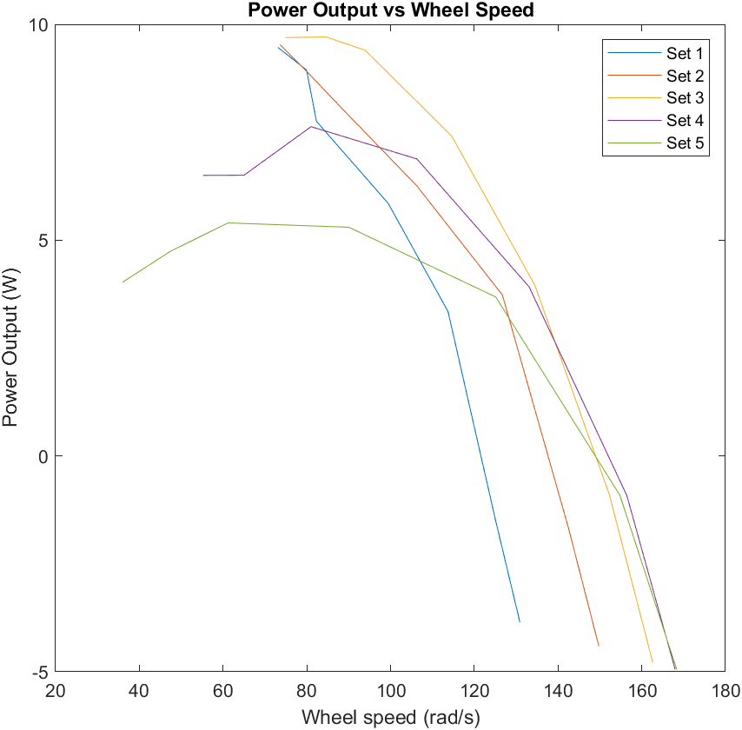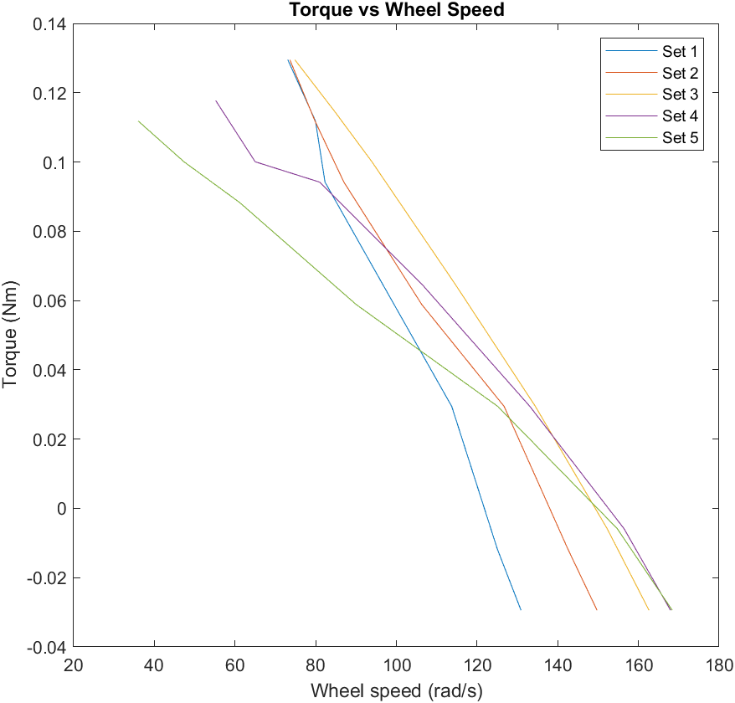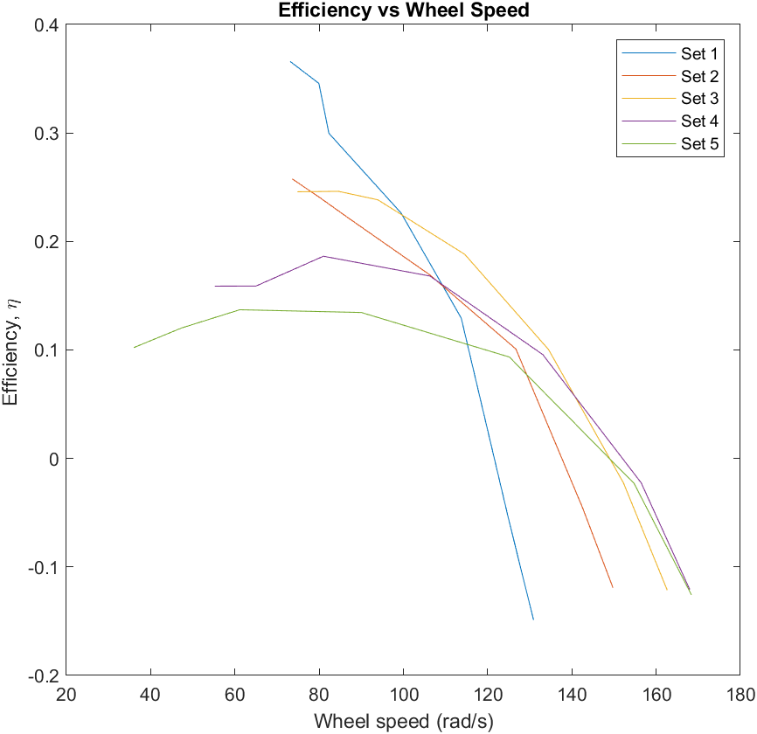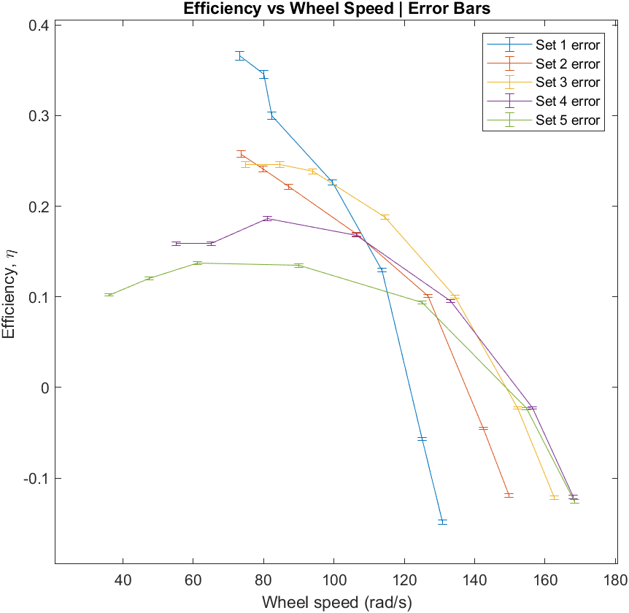

# Appendix C

# Appendix D

clc

clear

close all

set(0,'DefaultFigureWindowStyle','docked')

%% 0 | Data

set(1).p = 0.5; % bar

set(1).t = 38.66; % s

set(1).q = 0.5173; % L/s

set(1).m = [0, 100, 300, 500, 700, 800, 900]; % g

set(1).springm = [0.1, 0.14, 0.2, 0.3, 0.38, 0.42, 0.46]; % kg

set(1).wheel = [1250, 1194, 1086, 949.5, 786, 763.4, 698]; % rpm

set(2).p = 0.7; % bar

set(2).q = 0.5284; % L/s

set(2).t = 37.85; % s

set(2).m = [0, 100, 300, 500, 700, 800, 900]; % g

set(2).springm = [0.1, 0.14, 0.2, 0.3, 0.38, 0.42, 0.46]; % kg

set(2).wheel = [1430, 1361,1210, 1015, 830.7, 762.2, 702.8]; % rpm

set(3).p = 0.9; % bar

set(3).q = 0.4381; % L/s

set(3).t = 45.65; % s

set(3).m = [0, 100, 300, 500, 700, 800, 900]; % g

set(3).springm = [0.1, 0.12, 0.2, 0.28, 0.36, 0.41, 0.46]; % kg

set(3).wheel = [1553, 1454, 1284, 1094, 897, 807.7, 714.7]; % rpm

set(4).p = 1.1; % bar

set(4).q = 0.3721; % L/s

set(4).t = 53.75; % s

set(4).m = [0, 100, 300, 500, 700, 800, 900]; % g

set(4).springm = [0.1, 0.12, 0.2, 0.28, 0.38, 0.46, 0.5]; % kg

set(4).wheel = [1604, 1494, 1271, 1015, 773.6, 620.7, 527.3]; % rpm

set(5).p = 1.3; % bar

set(5).q = 0.303; % L/s

set(5).t = 66; % s

set(5).m = [0, 100, 300, 500, 700, 800, 900]; % g

set(5).springm = [0.1, 0.12, 0.2, 0.3, 0.4, 0.46, 0.52]; % kg

set(5).wheel = [1608, 1478, 1195, 859.7, 584, 452.1, 343.7]; % rpm

breakwheel_r = (60e-3)/2; % m

g = 9.81; % m^2/s

%% 1 | Conversions and Torque

convq = 1/1000; % m^3/s

convp = 1e5; % Pa

convm = 1e-3; % kg

convwheel = (2*pi())/60; % rad/s

figure;

for i = 1 : length(set)

set(i).p = set(i).p .* convp;

set(i).m = set(i).m .* convm;

set(i).q = set(i).q .* convq;

set(i).wheel = set(i).wheel .* convwheel;

set(i).T = zeros(1, length(set(i).m));

set(i).T = ( set(i).m - set(i).springm ) * breakwheel_r * g;

plot(set(i).wheel, set(i).T)

hold on

end

title('Torque vs Wheel Speed')

xlabel('Wheel speed (rad/s)')

ylabel('Torque (Nm)')

legend('Set 1', 'Set 2', 'Set 3', 'Set 4', 'Set 5')

hold off

%% 2 | Power Input

for i = 1 : length(set)

set(i).p_i = set(i).p * set(i).q;

disp("Set " + i + " Power input = " + set(i).p_i + " Watts")

end

disp(" ")

%% 3 | Power Output

figure;

for i = 1 : length(set)

set(i).p_o = set(i).T .* set(i).wheel;

plot(set(i).wheel, set(i).p_o)

hold on

end

title('Power Output vs Wheel Speed')

xlabel('Wheel speed (rad/s)')

ylabel('Power Output (W)')

legend('Set 1', 'Set 2', 'Set 3', 'Set 4', 'Set 5')

hold off

disp(" ")

%% 4 | Efficiency

figure;

for i = 1 : length(set)

set(i).eff = set(i).p_o ./ set(i).p_i;

plot(set(i).wheel, set(i).eff)

hold on

end

title('Efficiency vs Wheel Speed')

xlabel('Wheel speed (rad/s)')

ylabel('Efficiency, \eta ')

legend('Set 1', 'Set 2', 'Set 3', 'Set 4', 'Set 5')

hold off

disp(" ")

%% 5 | Error and Uncertainty

time_u = 0.5*0.01; % s

vol_u = 0.5*5*convq; % m^3

p_u = 0.5*0.2*convq; % Pa

spring_u = 0.5*0.02; % kg

tacho_u = 0.5*0.1*convwheel; % rad/s

tach_u = [1248, 1254, 1263, 1247, 1240, 1241, 1245, 1245, 1244, 1240]; % rpm

tach_u = tach_u * convwheel;

x_bar = mean(tach_u);

N = length(tach_u);

x_sum = zeros(1, length(tach_u));

for i = 1 : N

x_sum(i) = (tach_u(i) - x_bar)^2

end

x_sum = sum(x_sum)

s_x = sqrt( (1/(N-1))*(x_sum) )

s_x_bar = s_x/sqrt(N)

DoF = N - 1

t_95 = 2.262

ep_u = t_95*s_x_bar;

b_u = tacho_u;

w_u = sqrt((b_u)^2 + (ep_u)^2);

figure;

syms W S r N t P V

for i = 1 : length(set)

eff = ((W-S)*r*N*t) / (P*V);

pS = subs(diff(eff, S), {W, S, r, N, t, P, V}, {set(i).m, set(i).springm, breakwheel_r, set(i).wheel, set(i).t, set(i).p, 20*convq});

pw = subs(diff(eff, N), {W, S, r, N, t, P, V}, {set(i).m, set(i).springm, breakwheel_r, set(i).wheel, set(i).t, set(i).p, 20*convq});

pP = subs(diff(eff, P), {W, S, r, N, t, P, V}, {set(i).m, set(i).springm, breakwheel_r, set(i).wheel, set(i).t, set(i).p, 20*convq});

pV = subs(diff(eff, V), {W, S, r, N, t, P, V}, {set(i).m, set(i).springm, breakwheel_r, set(i).wheel, set(i).t, set(i).p, 20*convq});

pt = subs(diff(eff, t), {W, S, r, N, t, P, V}, {set(i).m, set(i).springm, breakwheel_r, set(i).wheel, set(i).t, set(i).p, 20*convq});

eff_u = sqrt((pS*spring_u).^2 + (pw*w_u).^2 + (pP*p_u).^2 + (pV*vol_u).^2 + (pt*time_u).^2);

eff_u = double(eff_u);

errorbar(set(i).wheel, set(i).eff, eff_u)

hold on

disp(eff_u)

disp(" ")

end

title('Efficiency vs Wheel Speed | Error Bars')

xlabel('Wheel speed (rad/s)')

ylabel('Efficiency, \eta ')

legend('Set 1 error', 'Set 2 error', 'Set 3 error', 'Set 4 error', 'Set 5 error');